The Good Company Framework

# Homepage

Welcome in The Good Company Framework!

The objective of this web-application is to set you on the path of creating a company or a project that makes sense, solves real problems and will make you proud. You should not aim for fortune and glory. You should aim at building a better world every day.

All the steps you will go through are inspired from

* multiple entrepreneurship techniques such as The Lean Startup
* books like Start With Why (Simon Sinek)
* entrepreneurship courses from the Penn University

Steps 1: Define idea

Steps 2: xxx

Let’s begin!

Any question? Contact me!

# Step 1: Choose a problem to solve

*“As entrepreneurs, we have to sell a vision of a different future.” – The Art of The Start (Guy Kawasaki)*

*“The key to entrepreneurship is domain expertise. The way to become an expert on some domain is genuine curiosity. Starting a startup is just translating that curiosity and it should be done in the end of the process.” – Before the Startup (Paul Graham)*

Focus on solving problems that will make the world a better place.

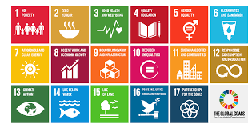

Which problem do you want to solve?

# Step 2: Start with Why

*“People don't buy what you do; they buy why you do it. And what you do simply proves what you believe” – Start With Why (Simon Sinek)*

The Golden Circle - Start With Why (Simon Sinek)

WHY: few companies know why they do it (ie. purpose, cause or belief)

Why do you want to solve this problem?

# Step 3: Define your solution

*“Don’t think too big too soon because first- most startups would fail the test of scaling at this point anyway, and second- it’s much more important to find a product that creates meaning” – The Art of The Start (Guy Kawasaki)*

*“The way to succeed is not to be an expert on startup but to be an expert on your users and the problem you are solving for them” – Before the Startup (Paul Graham)*

The Golden Circle - Start With Why (Simon Sinek)

WHAT: every companies know what they do

What is your solution to this problem?

# Step 4: For Whom Are You Solving This Problem?

Define the kind of persons having the problem you want to solve:

* Male / Female / Both
* Demographics
* Age
* How are they currently solving / mitigating their problems?
* Level of education
* Work experience
* Professional background
* Hard to find / to reach?

Focus on a focal market:

* Which market are you focusing on?
* Why this market?
* How big is it?
* Why would they switch to your solution?

# Step 5: Push and Pull Methods

Pull -> what other ways to solve this problem?

Push -> what other problems can you solve with your solution?

# Step 6: Define Yourself / Your Team

* Do you have the right skills to implement your solution?
* Do you have co-founders?
* What kind of skills do you need at first?
  + Tech, finance, legal, design, chemistry, …

# Step 7: Sum up your assumptions

* I believe the problem is …
* My solution to solve this problem is to ….
* I believe my typical personas are …
* Currently my personas are solving this problem by …
* I believe they will switch to my solution because …

# Step 8: Define your milestones

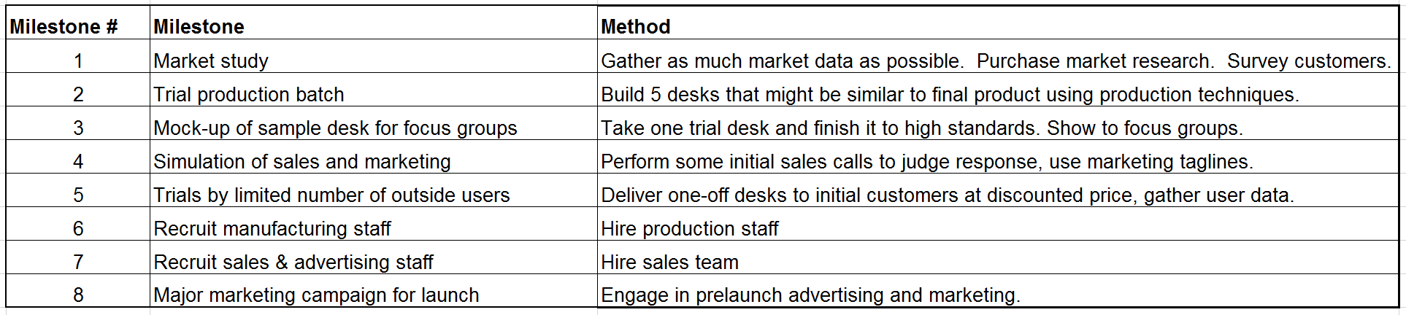

# Step 9: Let’s Tackle This First Milestone

Test your idea by talking to customers

# Step 10: Check your assumptions

* Is the problem real?
* Is it experienced by the personas you have defined?
* Is your solution really solving their problem?
* Are your personas currently solving this problem as you’ve expected?
* Are your personas willing to switch to your solution?

# Step 11: Pivot or Build MVP

* If all assumptions were correct -> build MVP
* If not -> pivot

Build you MVP with just enough features to solve the core problem.

